**SGGEE**

**Executive Committee Minutes**

**August 2015-July 2016**

**August 24, 2015**

The resignation from the position of Treasurer has been received from newly elected Susie Lewis due to personal and family reasons. We are pleased that she will remain on the finance committee. The Directors will begin the search for a replacement treasurer, someone who resides in Canada.

**September 14, 2015**

After correspondence with Ken Kufeldt, a motion by Sigrid Pohl Perry was made that Ken Kufeldt be authorized to be the interim Treasurer for SGGEE with full responsibilities as delineated in the guidelines for the position from September 14, 2015 until December 31, 2015 unless another member is found who can serve for a longer term. This was seconded by Melonie Liening. All voted in favor. Many thanks to Ken for his willingness to continue in this position.

**October 2, 2015**

Due to the 2014-2015 Financial report being inadvertently omitted from the August AGM, two motions were made by Sigrid Pohl Perry, a) that the Financial Report submitted by Treasurer Ken Kufeldt for the Annual General Meeting on August 7, 2015 but inadvertently omitted from the agenda be appended to the minutes of that meeting, and the same be published as appended to the minutes in the September 2015 issue of the SGGEE Journal; b) move that the SGGEE Board of Directors respond to this report in the same issue of the SGGEE Journal. Both motions passed. Ray Bloch, editor of the Journal, was notified.

**October 7, 2015**

Rose Ingram traveled to Calgary to transport the SGGEE library holdings back to her home in Kamloops via U-Haul where eventual sorting will take place. Ken Kufeldt met her at the storage unit to terminate the Maple Leaf storage rental agreement. Reimbursement request of $614.26 was submitted by Rose.

**October 8, 2015**

A payment request has been sent to Ken Kufeldt by Rose Ingram for Alex Brzhezytskyy for the last payment due for the Lutzk Indexing Project. “This is the last of this massive expenditure on this indexing project of the records from about 1900-1915 time period, which records are not microfilmed nor a copy anywhere except in the Archives of Zhitomir, Rowno and Lutzk”…Rose Ingram.

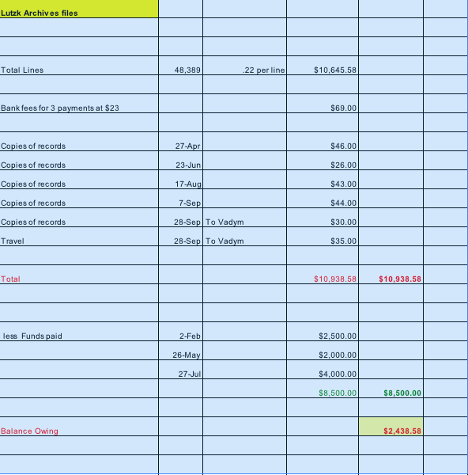

**October 19, 2015**

Matt Warner has updated the alias/committee lists on the SGGEE website for the year 2015-2016.

**October 29, 2016**

Annual Return form sent to Corporations Canada by Ken Kufeldt.

**November 1, 2015**

After discussion on the inability to change passwords on our website, Sigrid Pohl Perry moved that we authorize Matt Warner and Karl Krueger to implement a secure password change/reset procedure on the SGGEE website. A second was made by Edie Adam. Motion passed.

**November 8, 2015**

Directors’ Minutes 2015-2016 part 1 posted to Directors’ Only page on the website.

**October 31, 2015**

Financial statements for the first six months of the current fiscal year were received from interim treasurer Ken Kufeldt. He has added a new expense item under Administration---Cost of conversion to acquire US$. “This will become a major expense item as we go forward, given that the bulk of our income is in C$ but our expenses are mostly in US$. Unless the membership fee structure is modified this expense should be budgeted for in future fiscal years”….Ken Kufeldt.

**November 14, 2015**

It has been brought to our attention that the webmaster has been working under a handicap when he posts files on the Directors’ Only page of the website. He can get into the page to post them, but then cannot access the Directors’ Only section to test its functionality since he is not a Director. He has to ask one of the Directors to do this for him. The reason for this restriction was to preserve the security of the Board discussions. However, he is able to see the minutes when he operates as an administrator doing the uploads. A Motion by Edie Adam was made to grant the webmaster access to the Directors’ Only section of the website. It was seconded by Sigrid Pohl Perry. Motion carried.

**November 15, 2015**

Richard Benert commented on the challenge of doing lookups in the book “Liquidation of Volhynian Germans Property in the Years of 1914-1916, Nominal Lists” by Michael Kostiuk beings how it is written in Cyrillic and contains many lists that are not alphabetized. He suggested that if SGGEE begins to digitize books, this book may be a good one to begin with.

**December 3, 2015**

Sigrid Pohl Perry moved that a renewal of honorary memberships for 2016 be given to:

Alex Brzhezytskyy, Juergen Frantz AGoFF, Ansgar Mantey, Irmgard Mueller AGoFF, Brigitte Marufke AGoFF, Dieter Pechner AGoFF, Frank Stewner, Beate Harbich-Schoenert AGoFF, Matthew J. Warner and Rodney Frank.

A second motion by Sigrid was to offer Maria Kaucz a one year honorary membership since she has graciously offered to send SGGEE her books in Polish on the history of the Germans in Nowy Dwor parish. She has ancestry in this population and would be an exceptional contact for us according to some who know her website and her efforts. Both motions were seconded by Edie Adam. Motions carried.

**December 6, 2015**

Noted below are two of the emails sent to recipients receiving honorary memberships for this coming year who are associated with AGoFF. This form can be used as a model for future emails of this purpose. The model prepared by Sigrid Pohl Perry and used with her permission. Others receiving honorary memberships are listed in entry dated December 3, 2015.

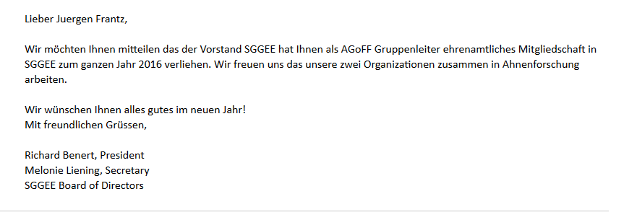

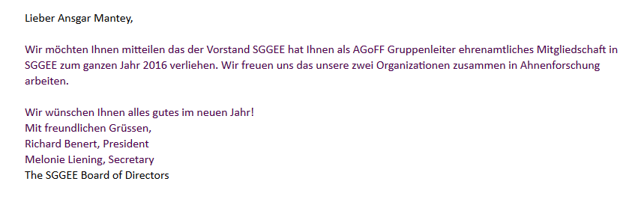

**December 17, 2015**

A motion was made by Sigrid Pohl Perry that the Board of Directors appoint Alan Pfahl treasurer of SGGEE from January 1 – August 31, 2016 with the understanding that he or another member will be elected treasurer at the August 2016 Annual General Meeting for a term from that meeting through August 2018. It was seconded by Edie Adam and passed unanimously.

**December 27, 2015**

Update by the convention committee with plans for the 2016 convention to be held at the Radisson Hotel and conference Centre Calgary Airport. The committee continues to hope that the 2017 convention will be a joint effort with the Polish genealogy group in the Chicago area. Sigrid Pohl Perry is our contact person with that group. There have been initial talks with GRHS regarding a joint convention in Bismarck, ND in 2018 but there is no further information on this at this time.

**December 29, 2015**

A deposit of C$ 1000.00 to be sent to the Radisson Hotel and Conference Center Calgary Airport towards our SGGEE convention in August 2016 by interim treasurer Ken Kufeldt.

**January 9 – 13, 2016**

Ongoing discussion with members of the Board and Finance committee regarding the disparity between US$ and C$. The goal is to have a solution at the annual convention in August, prior to membership renewal.

**January 10, 2016**

The 2016 SGGEE convention will be August 12-14, 2016 in Calgary, Alberta at the Radisson Hotel and Conference Centre Calgary Airport.

**January 11, 2016**

Change of Director form with updated Treasurer information sent to Corporations Canada.

**January 23, 2016**

The dates of the 2016 SGGEE convention in Calgary have been changed from August to July due to unforeseen scheduling changes by the hotel. The new dates are Friday, July 29 through Sunday, July 28. The venue remains the Radisson Hotel and Conference Centre Calgary Airport. Theme- Pack Your Research Toolbox.

**February 8-11, 2016**

Update by Sigrid regarding the 2017 calendar with Ernst Stewners’ photos of Germans in Poland in the 1930’s. Discussions regarding pricing and other potential German Russian groups that may be interested were made.

**February 16, 2016**

A motion by Edie Adam “to pay $600.00 USD toward the airfare to bring Alex Brzhezytskyy to Canada where he will attend and speak to the 2016 convention as well as provide translation services for the second Ukrainian speaker who is expected” was seconded by Sigrid Pohl Perry. Alex has been working with Don Miller on his Volhynia Village tours and also has been the point of contact for the Shitomir Archive index project. The convention committee has negotiated an agreement with Don Miller to pay 50% of Alex’s airfare to allow him to attend and present at the convention. He will prepare three presentations, two of which fall under the standing convention guidelines:

1) Presentation related to the index project; 2) Banquet speaker presenting a photo montage of the Volhynian villages. He will receive reimbursement for two nights hotel stay, free registration and banquet tickets for himself and a guest. The other speaker, Professor Mykhailo Kostiuk will have his travel expenses paid by the generous offer of Rita Lyster and family. SGGEE will pay for three nights hotel stay, his registration and banquet ticket. Alex will provide translation services as Professor Kostiuk does not speak English. The motion passed.

**February 15, 2016**

The convention publicity poster will be posted on the website and Facebook for people to download and share. Also, copies will be sent to publicity contacts.

**February 27, 2016**

After a brief discussion, convention speakers will be reimbursed with currency based on their residence as has been our practice in the past.

**March 26, 2016**

Convention registration form added to website and Facebook. Discussion continues regarding the $C and $USD disparity.

**March 29, 2016**

Reminder sent to committee chairpersons to submit their 2016-17 committee financial needs to Treasurer Alan Pfahl as the fiscal year ends April 30, 2016.

**March 24, 2016**

Final draft of the convention registration form to be inserted into upcoming Journal, the website and on the Facebook page.

**March 31, 2016**

Costs related to SGGEE distributing the 2017 Ernst Stewner Calendars at the Calgary convention have been studied. It was determined that by using the printer in Germany that the Stewner Family uses and paying bulk shipping to Canada, the price per calendar is cheaper than having it printed in Canada. The SGGEE logo and information about our organization will be included on the calendar. Cost for SGGEE per calendar will be approximately $CAN 5.30. Pre orders, convention sales as well shipped orders will be available. The Calendar will also be available at the Herder Institute in Germany which holds the photos. Two motions were made by Sigrid Pohl Perry: #1 That we pay Jake Belke $CAN 60.00 for the time spent receiving and the evaluation of the printing costs if printed in Edmonton; #2 That we include $CAN1500.00 in the SGGEE budget which begins May 1st for the printing and shipping of 200 calendars with the photos by Ernst Stewner. The second was made for both motions by Melonie Liening. Both motions passed.

**May 11, 2016**

The Request Payment/ Reimbursement forms were redesigned by Edie Adam- one for Canadian dollars and one for US dollars.

**May 16, 2016**

Convention program topics posted to website and Facebook page.

**July 18, 2016**

The revised secretary guidelines, moved by Sigrid Pohl Perry, second by Melonie Liening, were approved. The webmaster was directed to replace the current guidelines with the revised guidelines in the Members Only section of the SGGEE website.

**July 25, 2016**

A motion was made by Alan Pfahl to increase the reimbursement amount for travel expenses for Alex Brzhezytskyy by $ 127.36 for a total of $ 727.35, half of the full cost, in accordance with our agreement with Don Miller, which was made February 16, 2016. The motion was seconded by Edie Adam. Motion passed.

Respectfully Submitted,

Melonie Liening

Recording Secretary